Ferrocene models (ifeffit models) for Stagged structures with different kweight values:

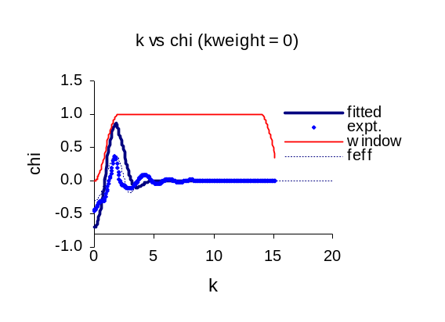
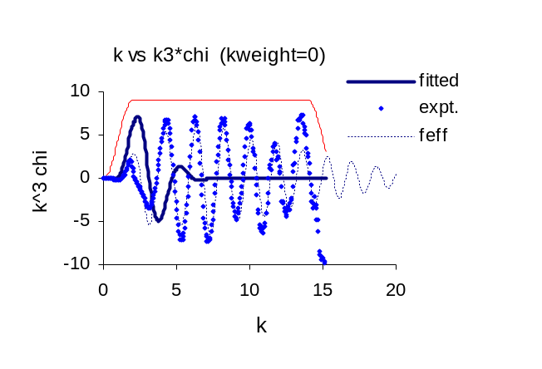

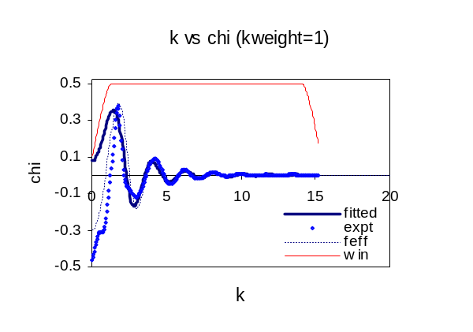
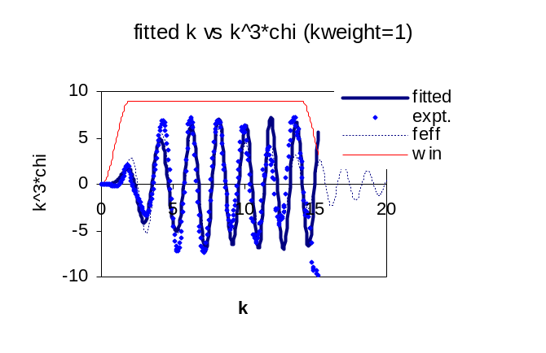

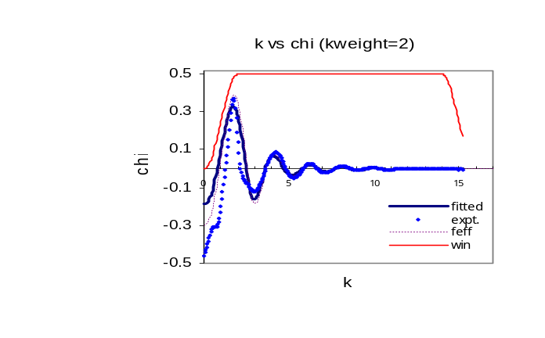
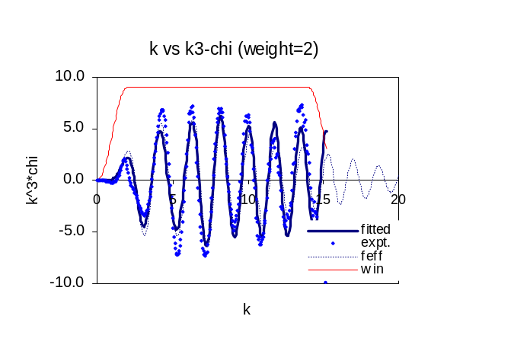

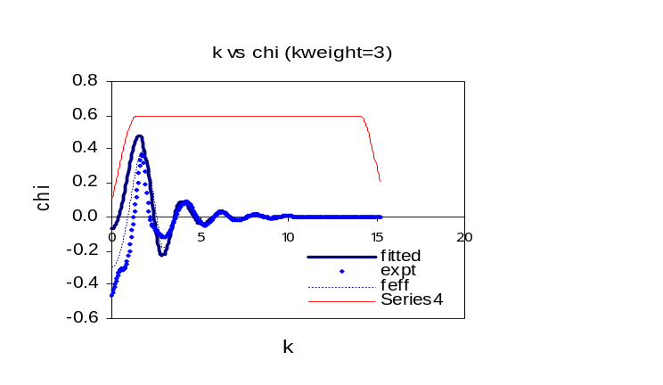
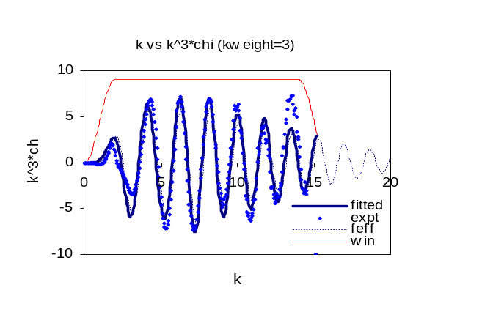

Ferrocene models (ifeffit models) for eclipsed structures with different kweight values:
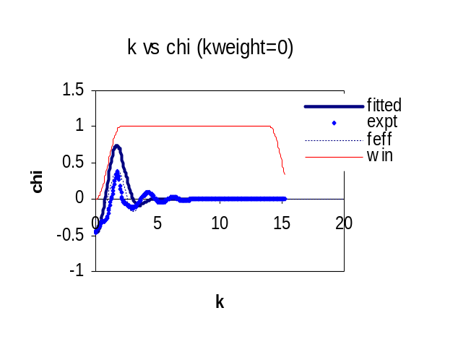
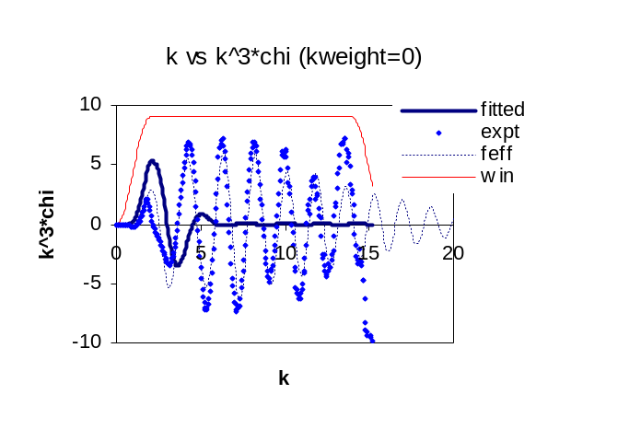

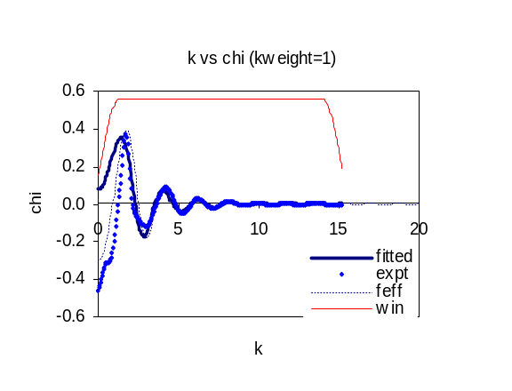
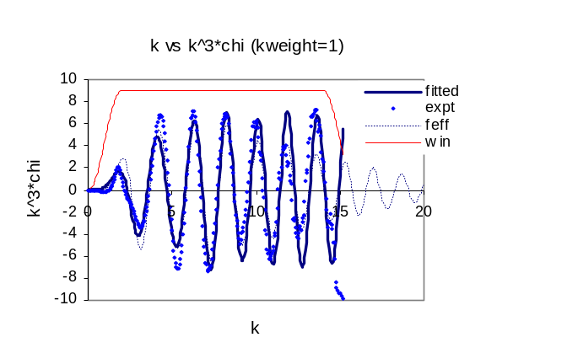

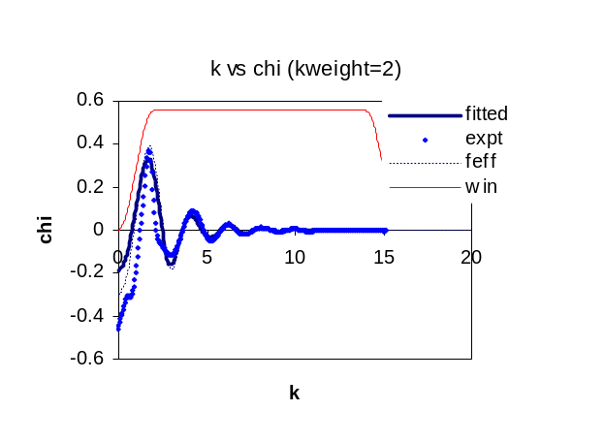
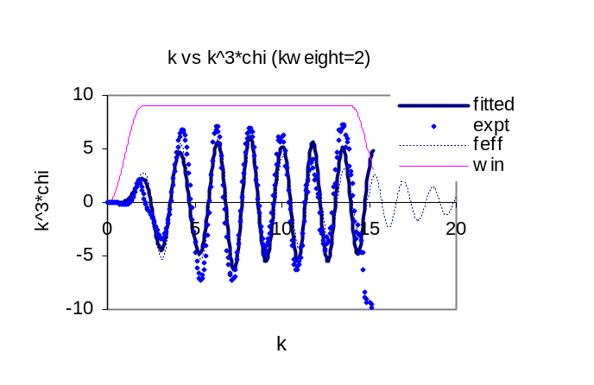

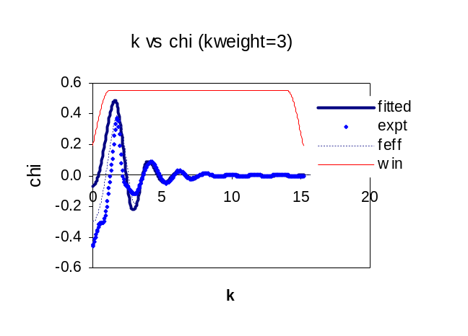
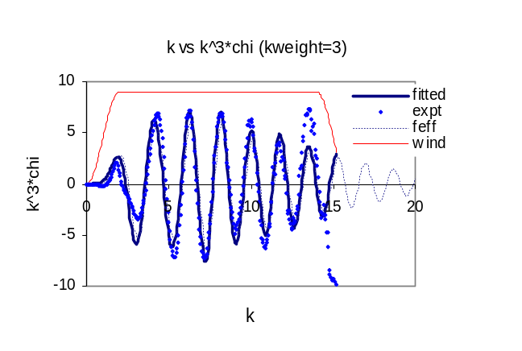

The model parameters for each of the paths were same except the kweight values. The ‘constant amplitude factor’ SO2 =0.75, Energy shift, e0=0.000, Change of path distance (∆R), DELR=0.000 and Mean square variation in the distance between the absorber and a scatterer (Debye waller factor σ²), SIGMA2 = 0.002467. In IFEFFIT, using sigma2 for a path to be Debye(t, theta), where ‘t’ is sapmple temperature and ‘theta’ is the character temperature.

The output parameters and χ² values ‘STAGGED’ were found to be as bellow:

Kweight = 0

# s02 = 11.866244
# e0 = -15.001820
# sigma2 = 0.69138827E-01
# delr = -0.24686754
# chi_square = 69082.830
# chi_reduced = 264423.597

Kweight=1

# s02 = 0.64517716
# e0 = -4.6521193
# sigma2 = 0.10112202E-03
# delr = -0.13705056E-01
# chi_square = 64672.453
# chi_reduced = 237264.782

Kweight=2

# s02 = 0.60950151
# e0 = -0.36391861
# delr = 0.11490004E-01
# sigma2 = 0.0006902429
# chi_square = 14913.121
# chi_reduced = 1087.758

Kweight=3

# s02 = 0.92666227
# e0 = -2.2480542
# sigma2 = 0.002728732
# delr = 0.10535116E-01
# chi_square = 2836.2361
# chi_reduced = 206.87412

The output parameters and χ² values ‘ECLIPSED’ were found to be as bellow:

Kweight=0

# s02 = 11.866244
# e0 = -15.001820
# sigma2 = 0.069138827
# delr = -0.24686754
# chi_square = 69032.940
# chi_reduced = 42826.000

Kweight=1

# s02 = 0.64545072
# e0 = -4.6551445
# sigma2 = 0.10292005E-03
# delr = -0.13727603E-01
# chi_square = 64664.564
# chi_reduced = 40293.00

Kweight=2

# s02 = 0.60969228
# e0 = -0.36858286
# sigma2 = 0.0006801436
# delr = 0.011473662
# chi_square = 13834.743
# chi_reduced = 1004.7232

Kweight=3

# s02 = 0.92665039
# e0 = -2.2488019
# delr = 0.010534926
# sigma2 = 0.0026596322
# chi_square = 2835.7261
# chi_reduced = 206.83692

In the models with different kweight values, the best fit was found to be kweight=3, the amplitude factors are consistent with the XFIT outputs.

Some issues of IFEFFIT:

The Debye and Einstein models both map a characteristic temperature to the thermal vibrations in a solid, and so to the sigma2 values for a scattering path. For very simple compounds (mono-atomic metals and some diatomic solids), these models work well for sigma2 for XAFS paths, and can be used to predict both the temperature dependence of sigma2 for a particular scattering path, and predict the values for sigma2 for different scattering paths at the same temperature. For more complex systems, the models are pretty close to worthless.

For calculating thermodynamic properties, the differences between the two models can be significant, but for XAFS they are not very different, though the characteristic temperatures are different. The Debye model does a better job at modeling sigma2 for multiple-scattering paths (though, to be honest, none of this is "proven" to be right).

